Setting up Application Environment Docker CLI Installation

|  |  |
| --- | --- |
| Date | 14 November 2022 |
| Team ID | PNT2022TMID29761 |
| Project Name | Skill and Job Recommender |
| Maximum Marks |  |

**Step 1:** Download Docker from docker.com and install it by running the Docker Desktop Installer.exe file

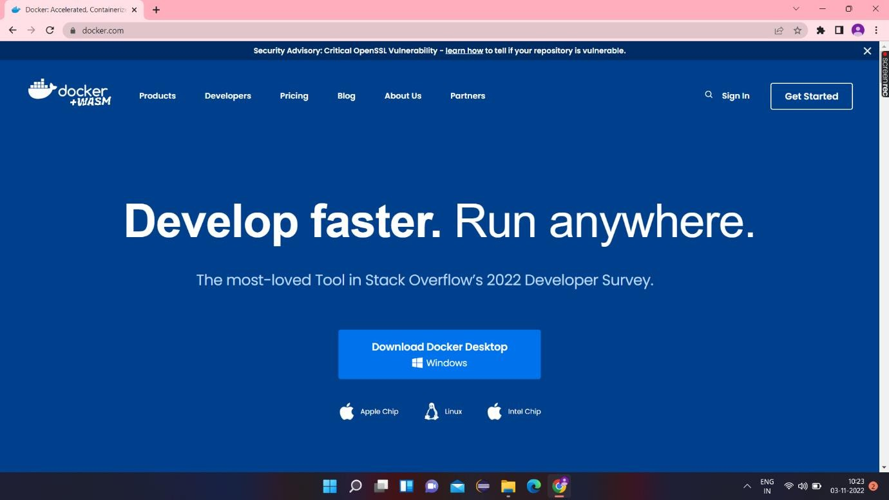

**Step 2:** Go to hub.docker.com register and create an account and login with the same

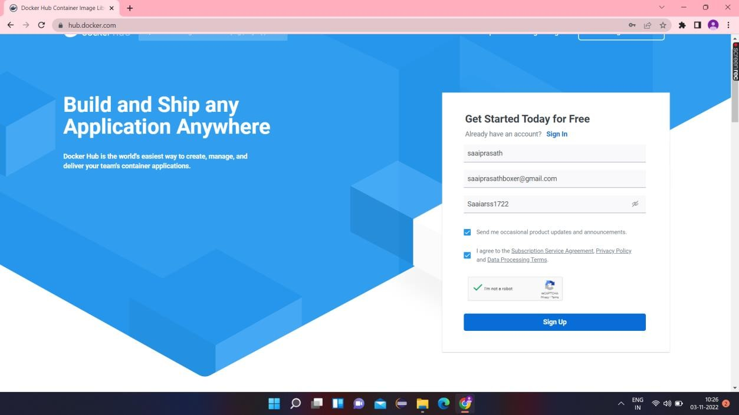

**Step 3:** Open Docker Desktop and start creating containers and images

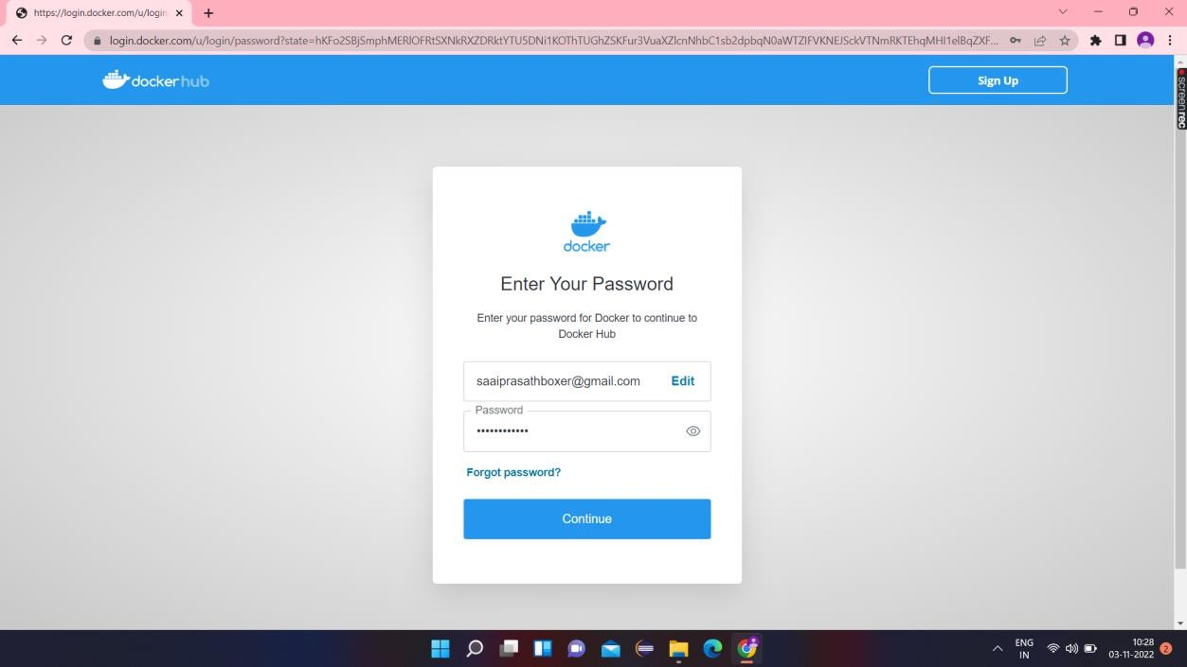

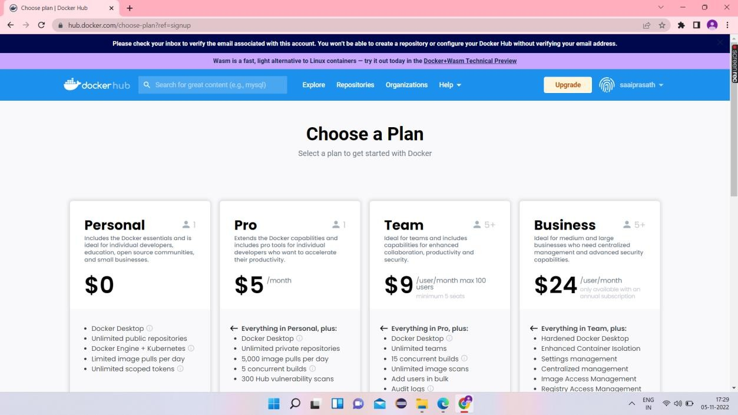

**Step 4:** Docker Desktop is starting

